**[17] Design Turing Machine Simulation For Palindrome W = ABABA C**

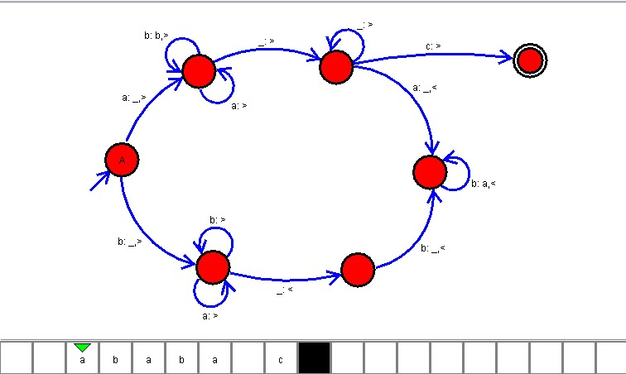

**Result**

The TM is designed to compute the given strings as input using AutoSim tool